VISTA
Human computer interaction in the smart city
Locicero giorgio | HCI | MAY 2023

Table of Contents
Table of Contents 0
ABSTRACT 1
INTRODUCTION TO THE PROJECT 1
QUESTIONNAIRE RESULTS 2
APPLICATION IDEAS AND CHOSEN ONE 9
PERSONAS 11
STORYBOARD 13
USE CASE 14
TASK MODELING 14
OTHER MODELS 15
MOCK-UP 18
PRELIMINARY EVALUATION 24
CONCLUSIONS 24

ABSTRACT
The final project will be centered around creating a system for the smart city, incorporating the opinion of a sample of the population (8-10 people) and concept of HCI and software design.

INTRODUCTION TO THE PROJECT
The concept of the project is the following:
I am part of an innovative company wishing to position itself on the niche of new interactive applications that could be used in the connected and intelligent cities of today and tomorrow; we talk about Smart City. The idea is to propose an interactive application, integrated in a way that could be described as natural in the city, that makes you want to interact with it, that is easy to use. It could be intended for different types of people in the city, with various characteristics, with special needs in case of disabilities. It could help solve certain problems, assist in certain activities, help people get around better, ask questions, make decisions, access certain information, services, etc. My company would like to have a specification file for an interactive application used in the connected and smart cities of today and tomorrow; this specification must be associated with initial evaluation data. This file must allow convincing new partners in order to submit together proposals to national, European or international calls for tender in the field of the Smart City.
I will organize all the models based on HCI design techniques seen during the course in the following chapters.
The system acronym that was thought of for the project is VISTA (Volunteering and Event-based Information System for a Smart City), to make the people know about the evaluation aspects of the projects.
In the first part of the project, a questionnaire was submitted to a small sample of the population with age range of 20-30 and living across different Italian cities (Torino, Bologna, Catania).

QUESTIONNAIRE RESULTS
The first question submitted to the sample population is about the transportation in the city where they live and if they are satisfied with it:
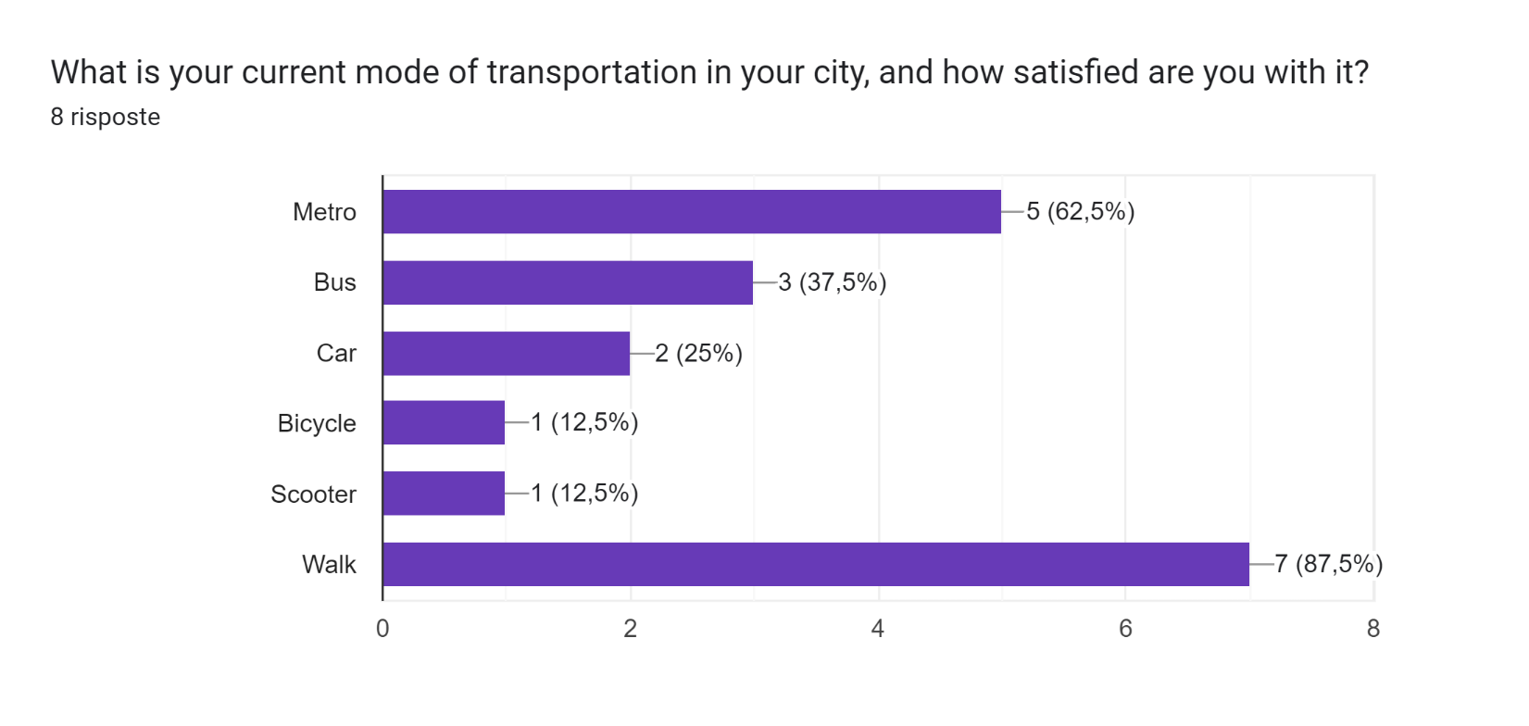
Most of the people walk in the city, I should say that most of the people that I have submitted to the questionnaire are quite young so that could be seen as a bias for the results of this questionnaire as a whole but it could also show that most of the younger generation uses the most efficient and environmentally friendly ways of transport to travel in the city.
The second question is about the improvements in the city that the people desire.
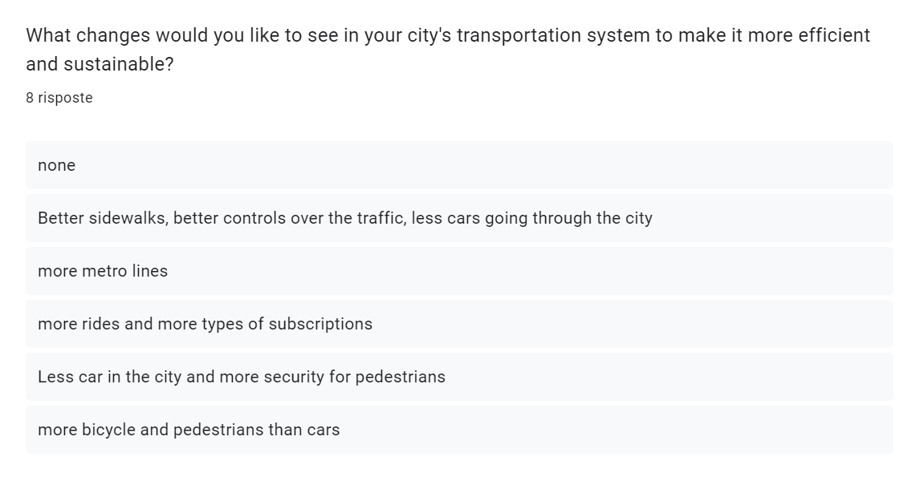
It seems that most people need pedestrians services, bike services and metro services, so the need for these things in the smart city is desirable.
The next question is about the safety of the city:
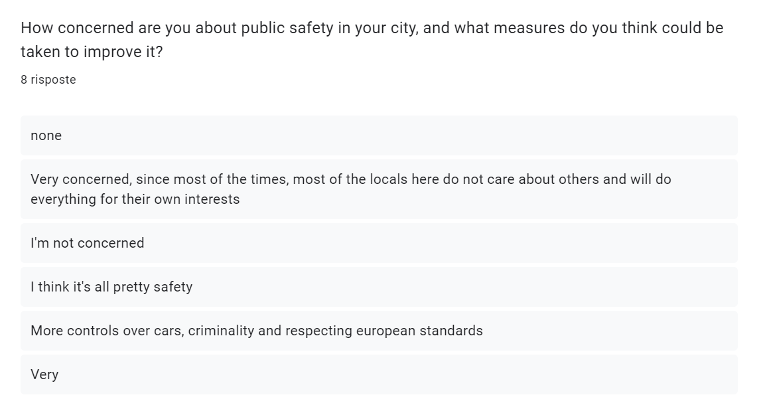
Most of the people seem to be satisfied with the safety in their city, while some desire for more controls over rules and regulations.
The next question is about energy efficiency and sustainability in the city of the person taking the questionnaire:
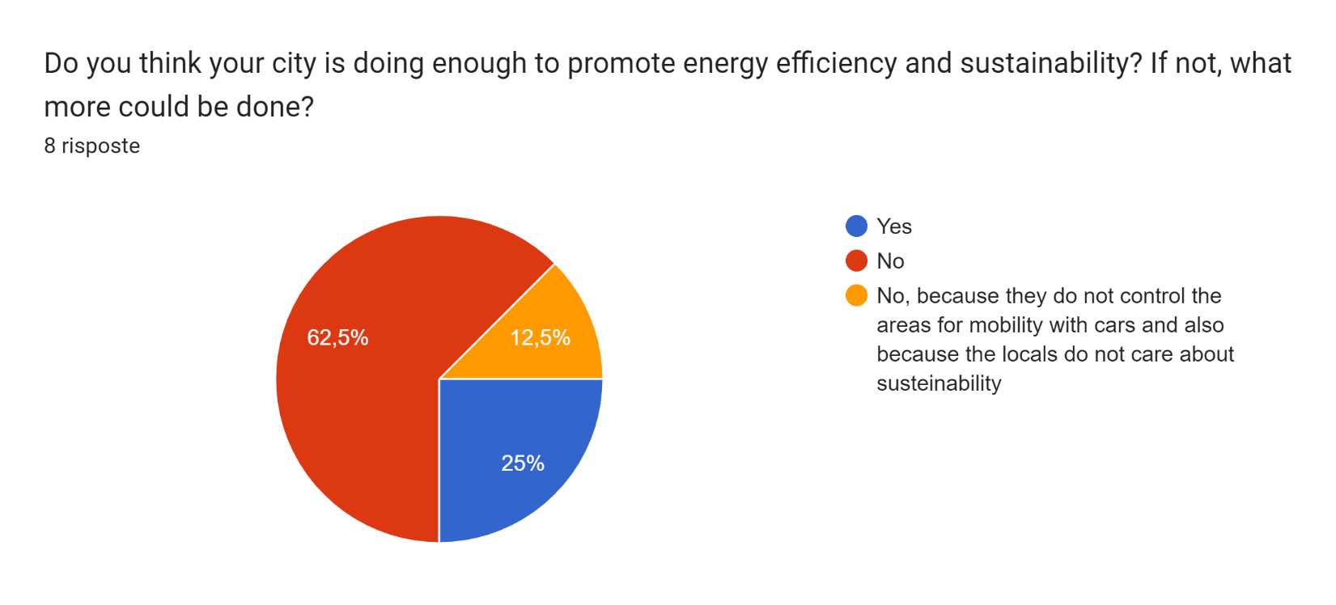
Most of the people think that the city is not doing enough for sustainability and efficiency, so the possibility of integrating more of these topics into the smart city both in the form of spreading information, regulations and using new tech to do it should be a must in the smart city.
The next question is about accessibility to public services:
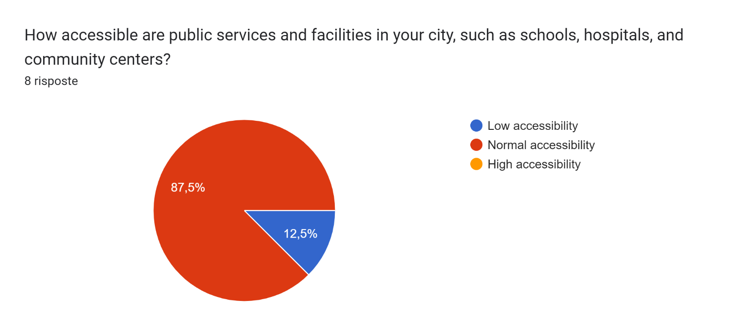
Normal accessibility seems to be the norm in the cities of Catania, Torino and Bologna, but it is probably not the norm in more rural cities.
The next question is about the connection to the community and the measures that could be taken to improve social cohesion and engagement:
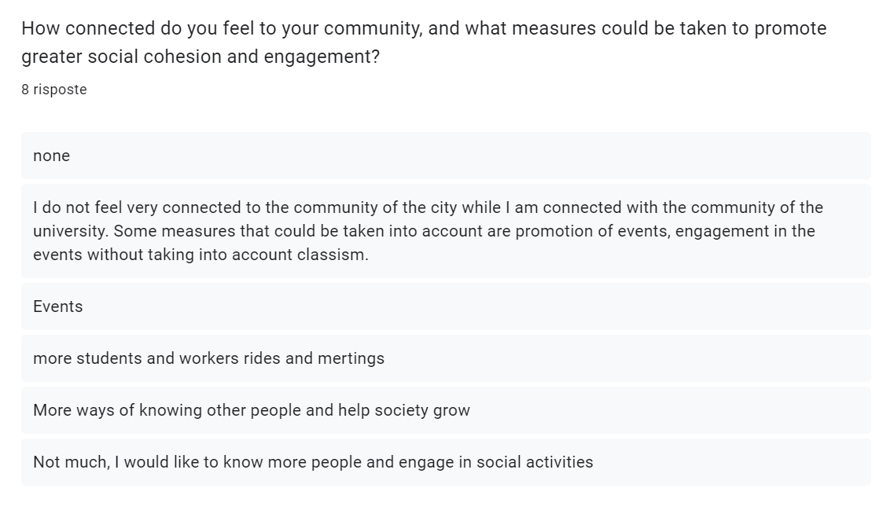
It seems most people do not feel very connected to the community and are in search for a way to join some events and to help society grow, this point will be very important since the application that will be thought will revolve around events and helping society grow.
The next question is like the previous one but pones the problem of understanding the challenges of growth for the smart city environment:
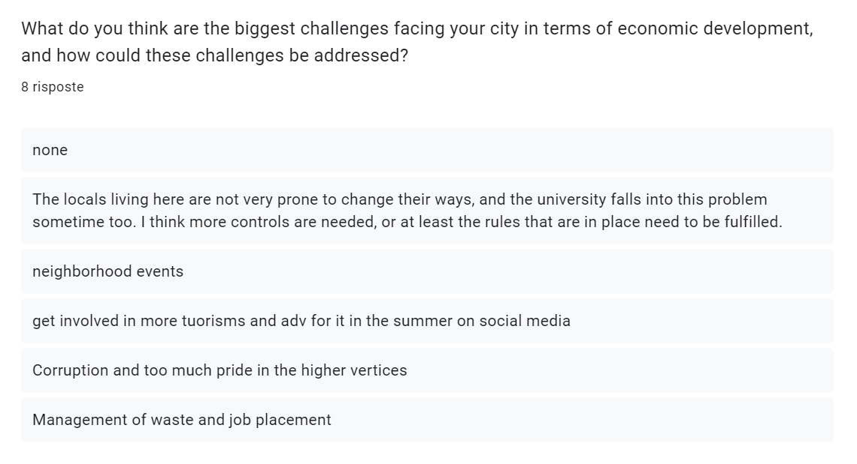
Similar to the previous question, there is the need to participate in events and make the population participate in things like politics (to aim at corruption), tourism (with events that involve international relations), management of waste and jobs (with volunteering event and masterclasses), etc...
The following questions are about public spaces and green spaces in the city:
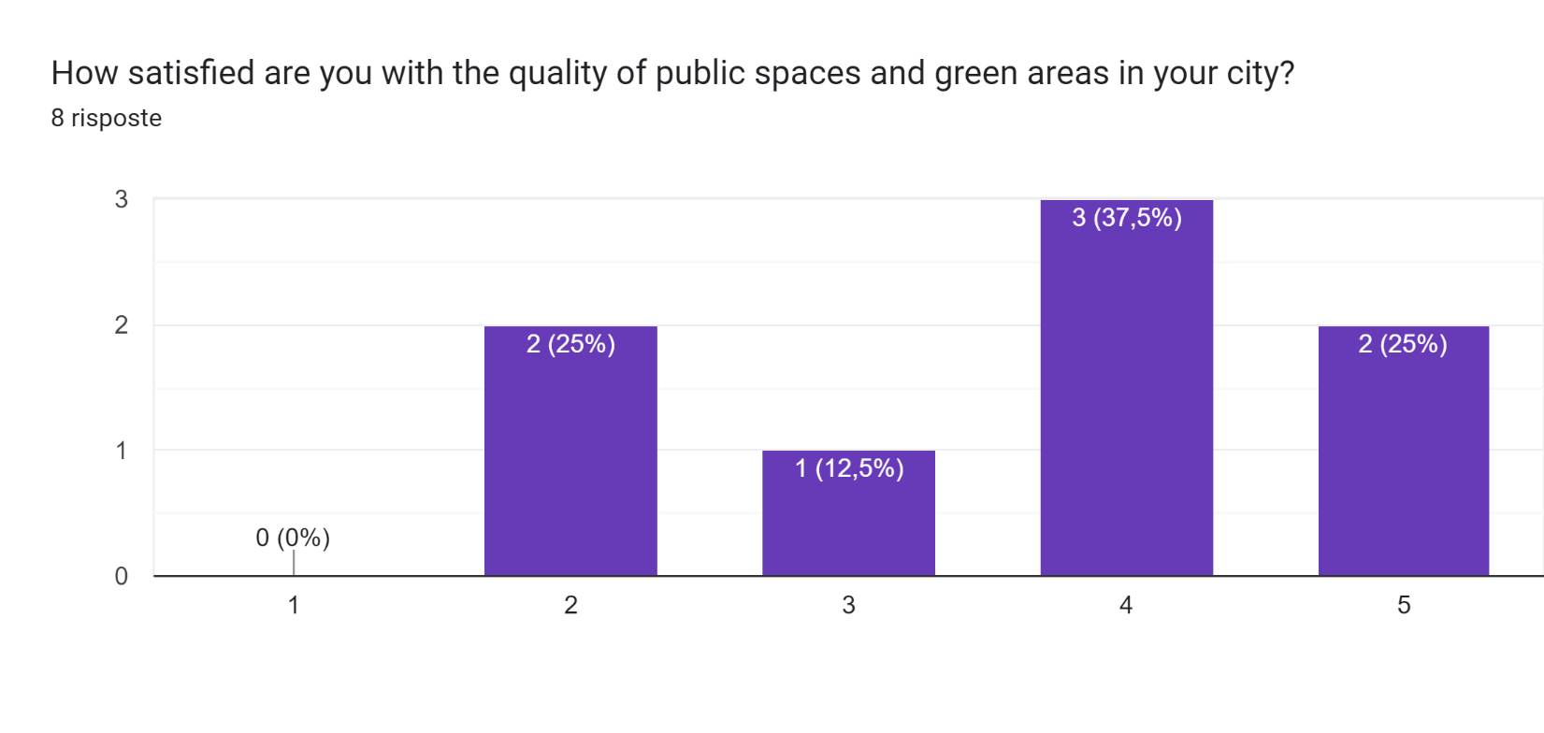
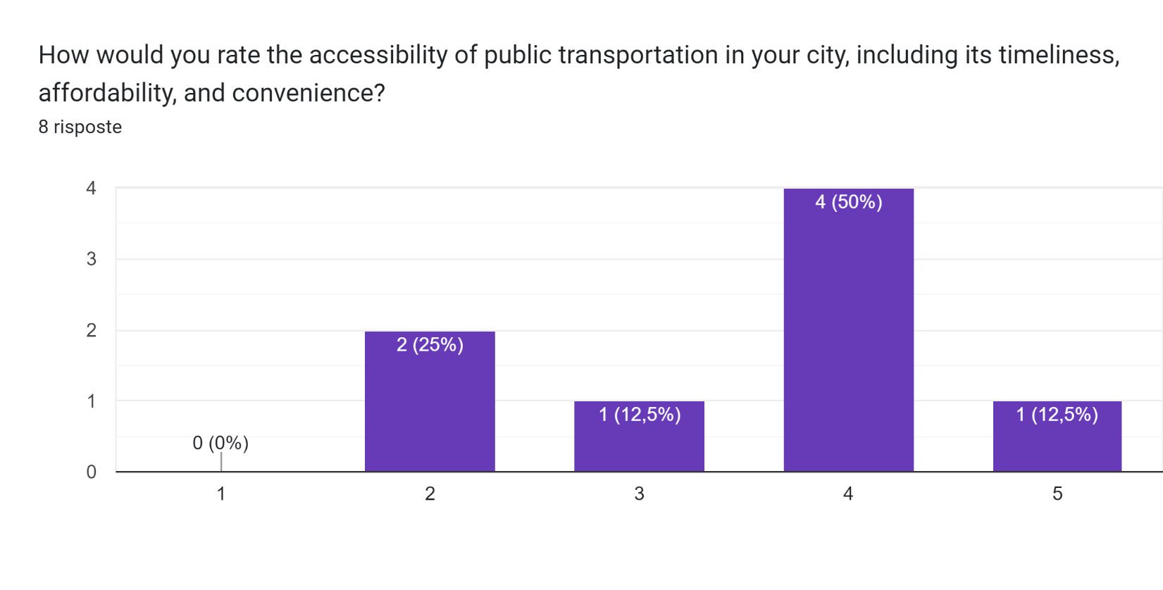
Most of the people feel ok with the public spaces and transportation in the city where they live in.
The following question was about addressing the case of natural disasters in the city and the preparation in case of emergencies.
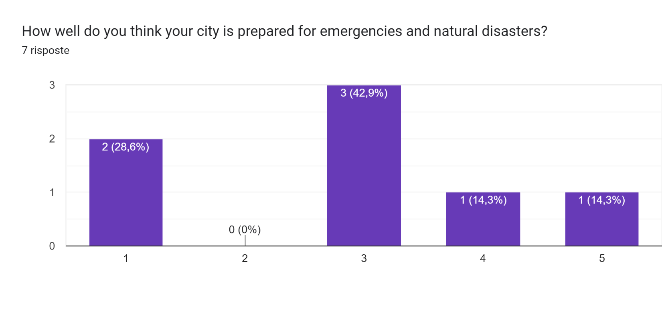
The opinion seems to be that the city could be better prepared for these kinds of situations.
The next question is more focused on the technologies that should be implemented in the city:
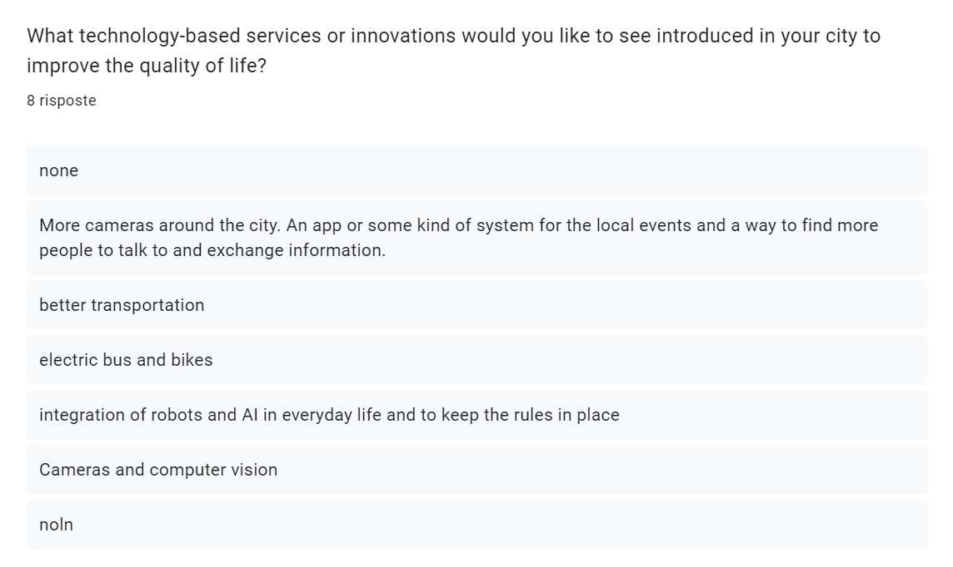
The consensus is for a better transportation system and electric buses or bikes, more cameras, and more integration with AI (Artificial Intelligence) and robots.
The next question is about priority for pedestrians and bikes infrastructure in the city:
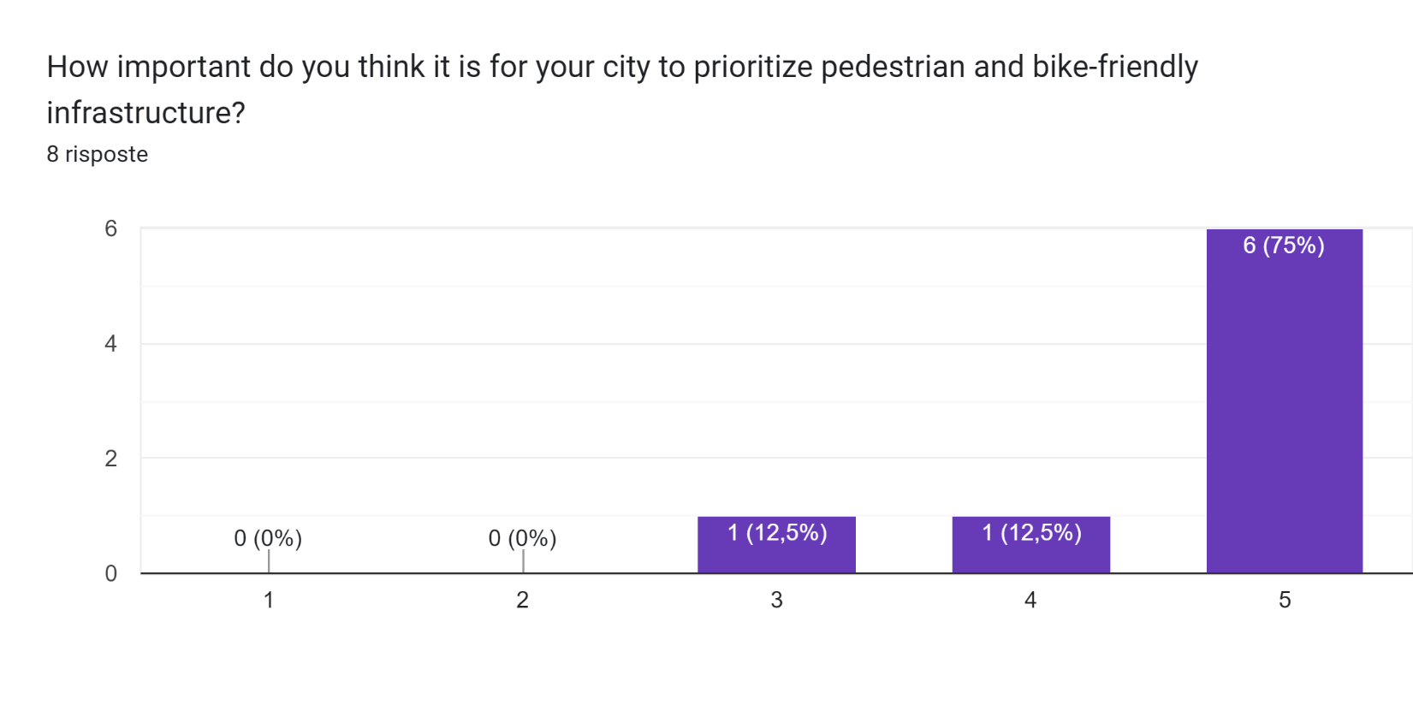
There is an obvious consensus about the integration of these infrastructures in the city.
The next question is about the measures that could be taken for sustainable waste management:
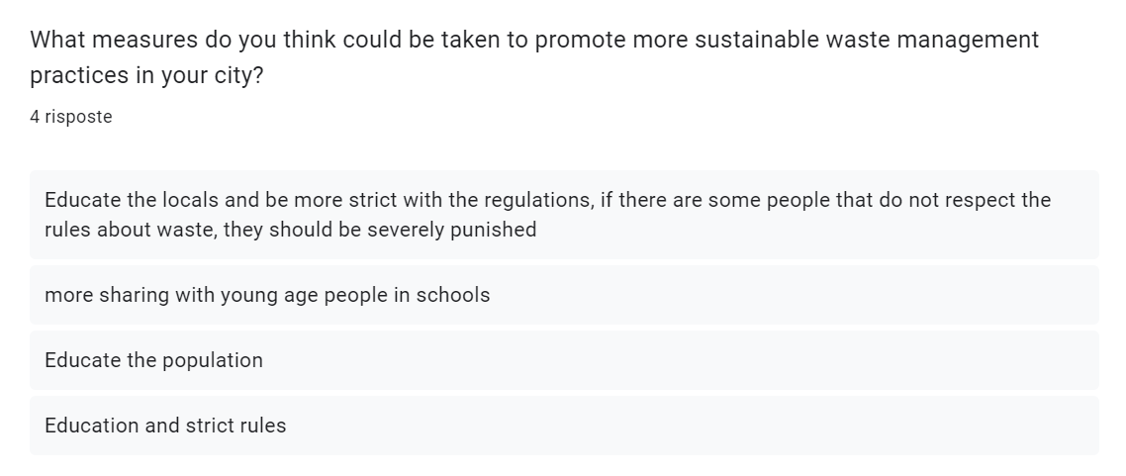
Education comes as the consensus opinion, although I do not think that the problem is of the younger population but the older population since they come from different times and are not that quick to change in their habits, especially in southern Italy.
The next question is about high-speed internet:
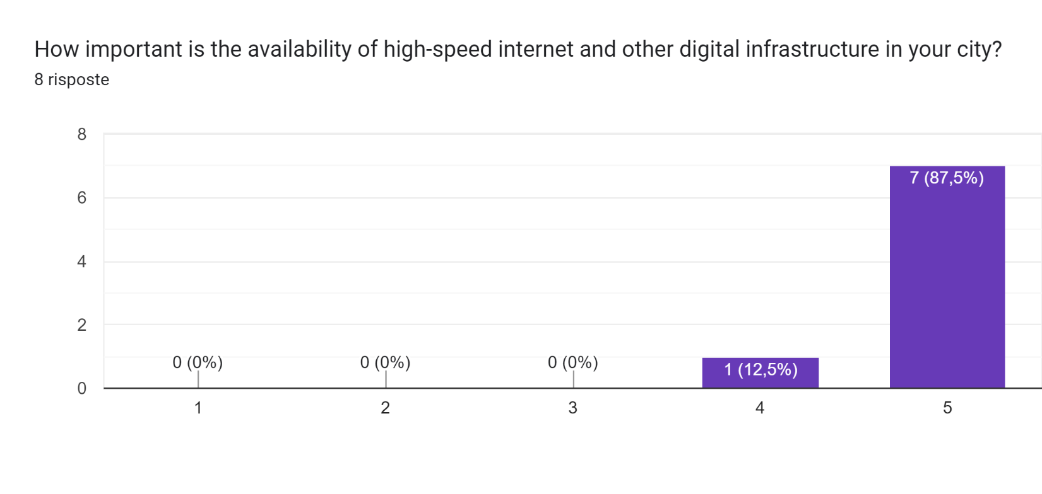
There is an obvious consensus about high-speed internet and digital infrastructures in the city.

From these questions, the main ideas that have been seen are:
- Walking and the metro is the preferred way of traveling in the city (the people that have submitted the questionnaire all come from Italian cities, mainly Catania, Torino, and Bologna)
- Waste management in the city is ok but some people have commented on how the residents do not respect the rules in place for waste management.
- energy consumption and efficiency are relevant but not in the minds of the commoner, so the possible solutions for smart city integration should be done by the government to reduce the overall consumption of the city and the residents without making them feel the difference.
- Traffic controls are not respected by the people in these cities, and pedestrians or people without cars are often endangered in some way. The same thing could be said about safety in the city in general.
- High-speed internet is fundamental but available in the cities where the people that have taken the questionnaire are living.
- Some people would like to find a way to connect and engage in the community.

APPLICATION IDEAS AND CHOSEN ONE
The ideas that could be done given the previous feedback from the people are the following:
- Implement smart crosswalks that detect when a pedestrian is about to cross and automatically adjust traffic signals to stop cars and allow safe crossing. The system could also use computer vision to detect pedestrians and alert drivers when someone is about to cross.
- Use computer vision to monitor and analyze traffic patterns and adjust traffic signals in real-time to optimize traffic flow and reduce congestion. The system could also detect and alert authorities to accidents, not respecting the rules, or other incidents on the road.
- Develop a smart waste management system that uses AI to optimize garbage collection routes and schedules based on real-time data on waste levels and traffic conditions. The system could also use machine learning to predict future waste levels and adjust collection schedules accordingly.
- Install solar panels on city-owned buildings and facilities to generate renewable energy and reduce dependence on fossil fuels. The city could also develop a smart grid that integrates renewable energy sources and optimizes energy distribution and consumption based on real-time data.
- Implement a smart lighting system that uses sensors to detect when a room or area is empty and automatically adjusts lighting levels to reduce energy consumption. The system could also use AI to learn occupancy patterns and adjust lighting schedules accordingly.
- Develop a smart city app that provides information on local events and activities, as well as recommendations based on the user's preferences and location. The app could also facilitate social connections by allowing users to connect with others who share similar interests.
- Develop a smart community platform that connects residents with local businesses, organizations, and government agencies. The platform could allow residents to provide feedback, make suggestions, and get involved in decision-making processes.
- Use smart transportation systems to encourage social interaction and community engagement. For example, the city could develop shared transportation services that encourage residents to ride together and get to know each other.
- Create a smart city program that encourages residents to participate in community-building activities, such as volunteer work or neighborhood clean-up events. The program could provide incentives or rewards for participation and could use technology to track and measure participation rates.
The first five proposals are more on the implementation and AI side of the problem so I will not consider them, while the other ideas will be used as the skeleton for this project, to create an app for volunteering events (participation in politics, cleaning and planting, spreading information and helping people in needs, contribute to the development of the city with their skills) where people will participate in a specific role.
The project will have a mock-up as a web application, but it should be noted that the implementation will be done with mobile apps and visualization in mind since most of the interactions with the system will be done directly on the phone.
Integrated with the system, there will be an evaluation module, where people and AI will work together to see the results of the event and the contribution of the specific volunteer.
In the following section, two personas will be seen to understand the importance of some application for these kinds of needs.

PERSONAS
The first persona that was considered is a mother that spend most of his time with her kids, but also wants to participate in volunteering events since she doesn’t have the time to search for them and to participate in them given the strict rules usually in place for these events.
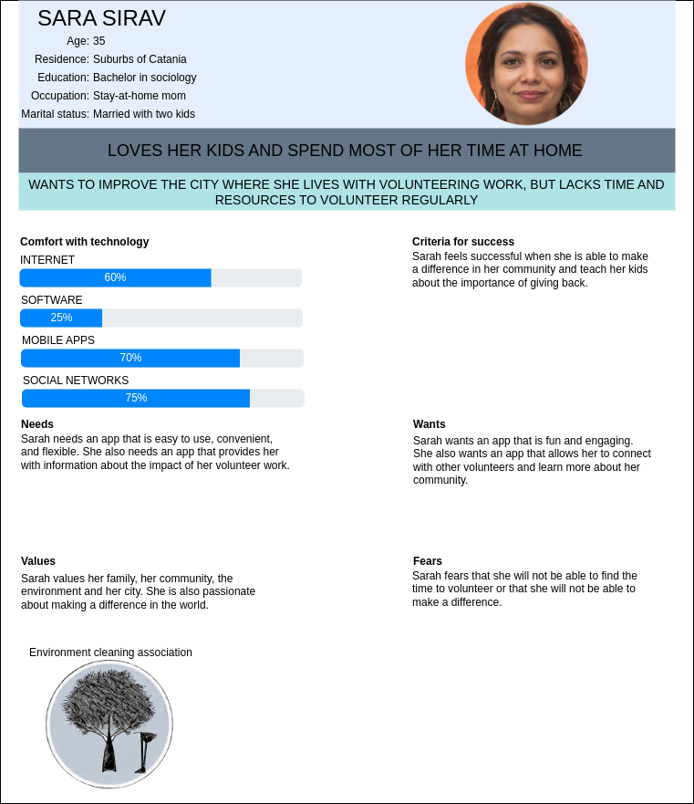
The second persona is a software engineer that wants to contribute to the city where he lives but doesn’t want to get involved too much with the city government and bureaucracy.
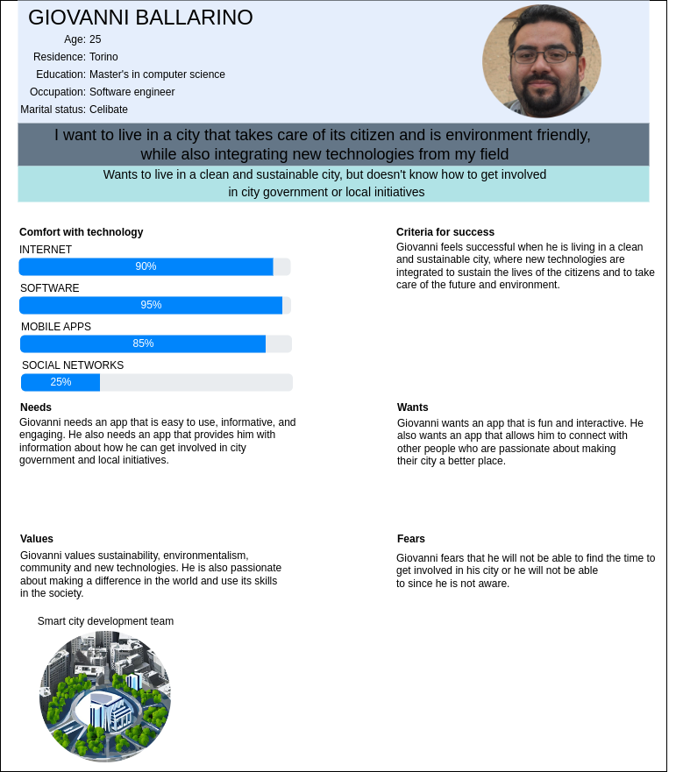
These two personas illustrate two different fields of participation to events in the city with the same root, try to help the city grow and using their skills to make some change where they live.

STORYBOARD
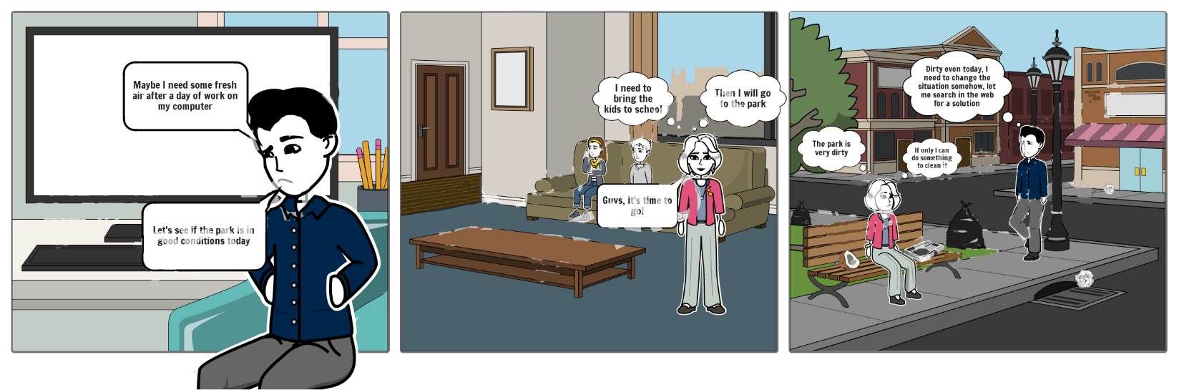
The storyboard created illustrates a situation where two types of people want to go out and find some peace after a day of work but find themselves in a park full of waste and trash, where new people that comes there contribute to the filth and the municipality has lost interest in it since it becomes unmanageable very quickly.
This storyboard illustrates two characters like the personas seen previously, these two characters represent the need for a way to help the city and, in this case, help with the cleaning of a park. This tries to convey the need of these people, coming from two diverse backgrounds, to change the ways of their city for the better and to integrate modern technologies into everyday life for a better result.

USE CASE
For the use case, the case of joining an event was chosen since it should be the most important action in the system.
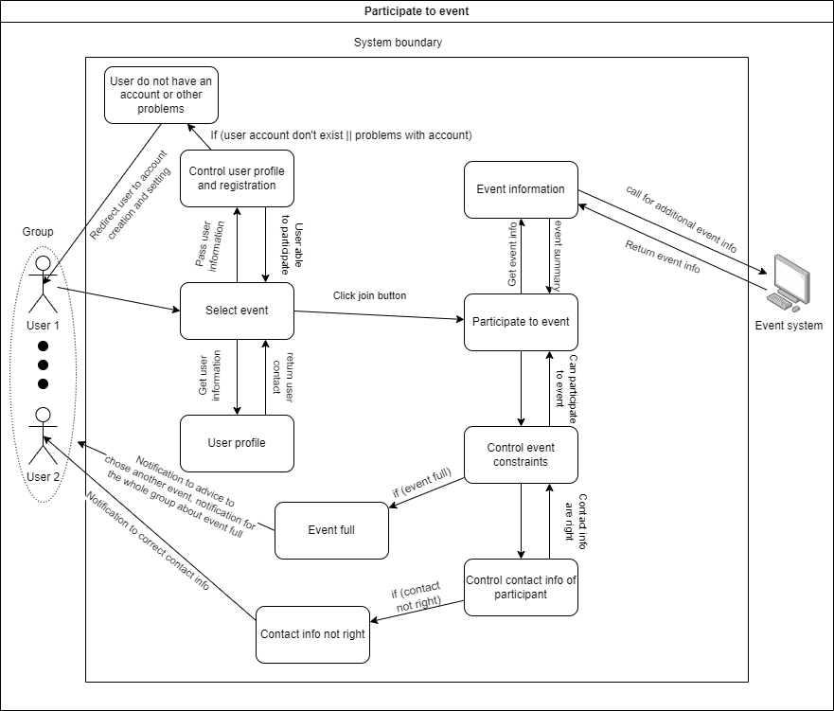
The user will try to join an event after having selected it, then some controls for suitability will be done to understand if the user is suitable for the event (based upon the policy of the system and of the event itself, established by the organizer of the event). If anything is wrong with the user or the event, the user and the organization will be notified. If the user joins the event, a notification will be sent to the organizer, also other cases are possible, when the notification is sent to all the people that have already entered the event.

TASK MODELING
For the task modeling, three tasks were identified to be the most important for the system for two user type of the system, that is an organization trying to create an event, and a user that is trying to join an event, while another model was also included for the evaluation of the event itself, even though there shouldn’t be enough interaction with users or organizations to be directly correlated to user interaction(there is some users interaction in between the evaluation though since the evaluator role and the users that have participated to an event are asked for a feedback about the event itself). The first task that was modeled with the CTT model was the creation of an event by an organization, where the organization initiate the possibility of creating an event with all its details, as can be seen in the following figure of the CTT model
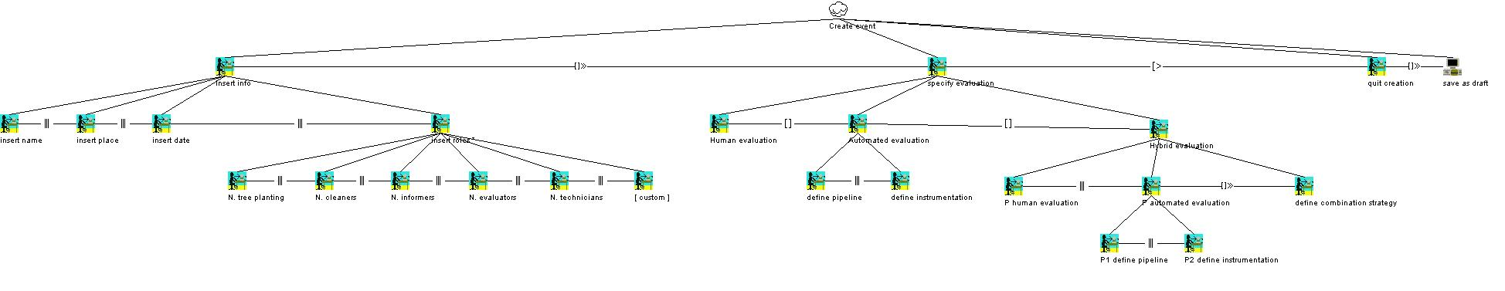
The most important part of the CTT model are:
- The specification of the information of the event, like name, place, date and roles available for the event.
- The specification of the evaluation of the event and its users, with the possibility of using human evaluation, automated evaluation or the hybrid approach, combining both human feedback with automated evaluation.
- The possibility of stopping the process of creation of the event, after having it stopped, the event is stored as a draft.
The second model that will be seen is the one built for the task of evaluation of the users and the event.
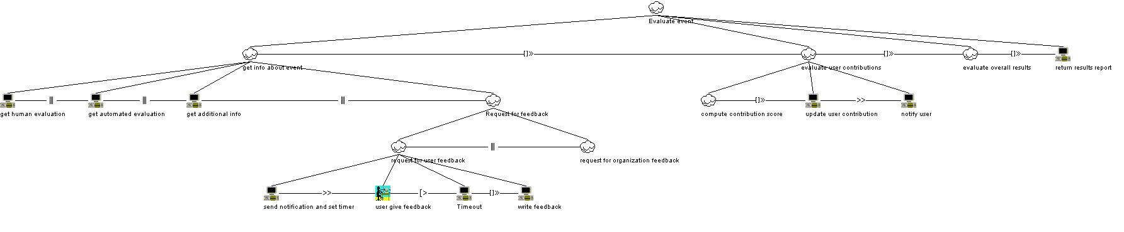
The task is divided into a pipeline that takes the info about the event, along with some optional feedback from the users, evaluates the contributions of everyone that has participated to the event, and computes an overall result for the event itself.
The Last model that will be presented is the one for the selection of an event, where the event can be joined or unjoined, and the behavior changes accordingly.
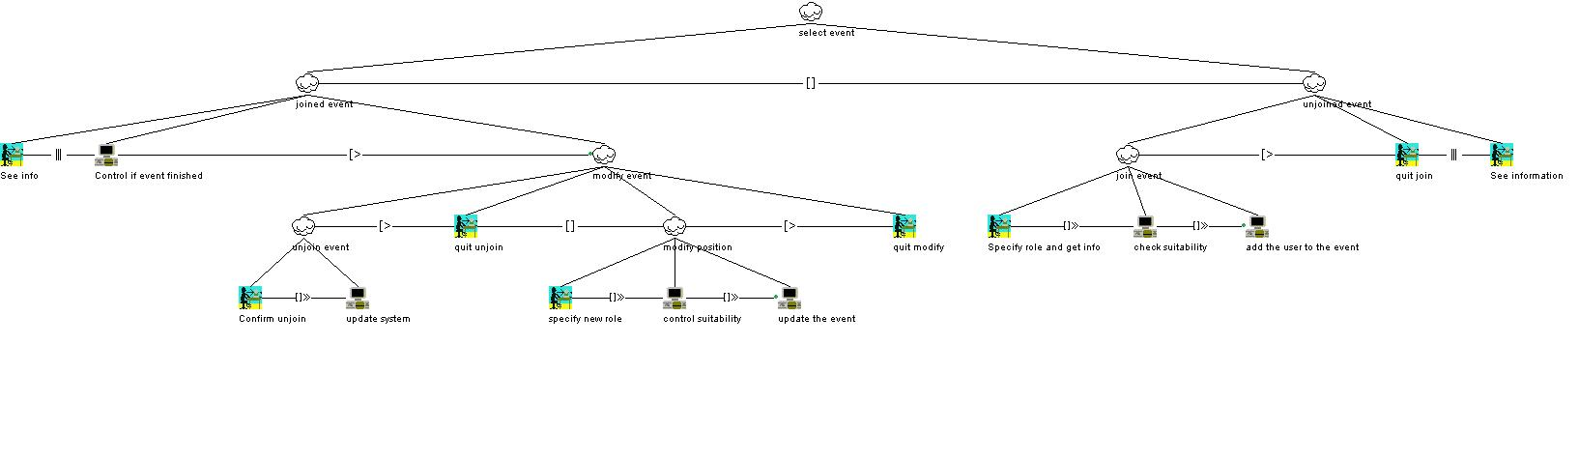
In a joined event, there are more possibilities to see the event and modify it (changing roles or unjoining the event itself), while, for an unjoined event, there are only the possibilities of seeing the information about the event itself, joining the event or stopping the joining of the event.

OTHER MODELS
The first of the additional models chosen for the system is a petri-net model, where every state is characterized by several places, representing the rarity of the state itself.
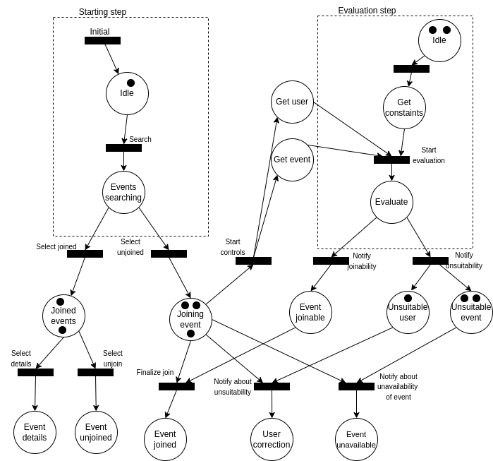
The design is like the use case, but in this case seen in the previous chapter, there is a clearer definition of the process and how the system finds itself in some states after an action.
The next model is a classical UML class diagram, where the system is represented as classes with the relation between them. I have also added some virtual containers for complex parts of the system that I cannot model e they are out of the scope of this project, are already defined models (Notification system) or are dependent on the environment where the system is deployed (Evaluation system).
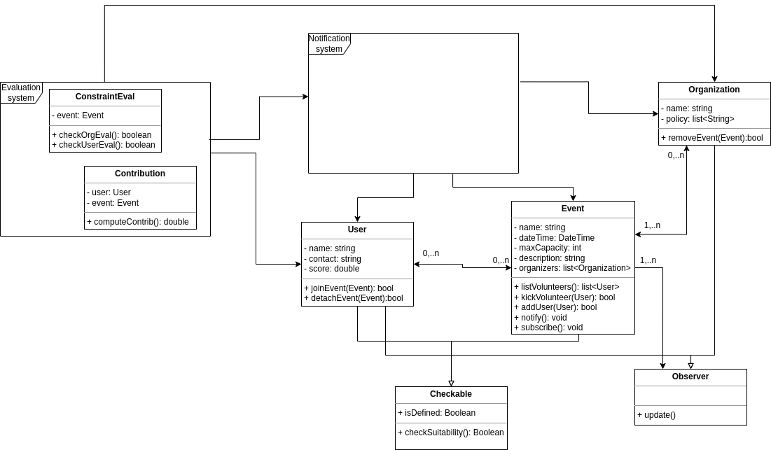
It should be noted that the event, user, and organization classes implement the design pattern Observer since when the event is updated in some way, the users and the organization should be notified.
The next model is a sequence diagram for the joinEvent function:
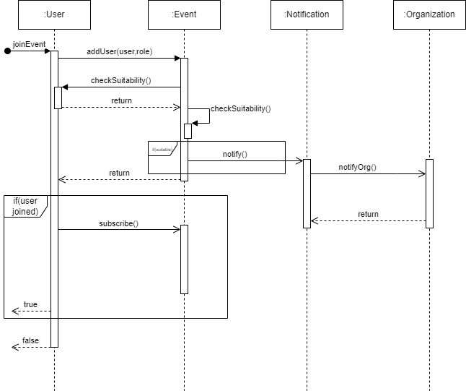
When the function is called, the user object tries to add itself to the event, the event checks the suitability of the user and the event itself. If the suitability is satisfied, the user is added to the event, and the Organization is notified (for the Observer pattern, this sequence diagram also incorporates the Notification system previously mentioned). After this, the user checks if it was added to the event and subscribes to it if it is true, and returns true, otherwise, it returns false altogether without subscribing to the event.

MOCK-UP
Even though the following mock-up is done for a web application, the idea is to have an app directly on the mobile to reach more audience and be at the hand every time that someone needs to search for a volunteering event in their city.
The first page presented for the mock-up is the login page, where the logo is shown and the login form is presented along the possibility of signing up for an account.

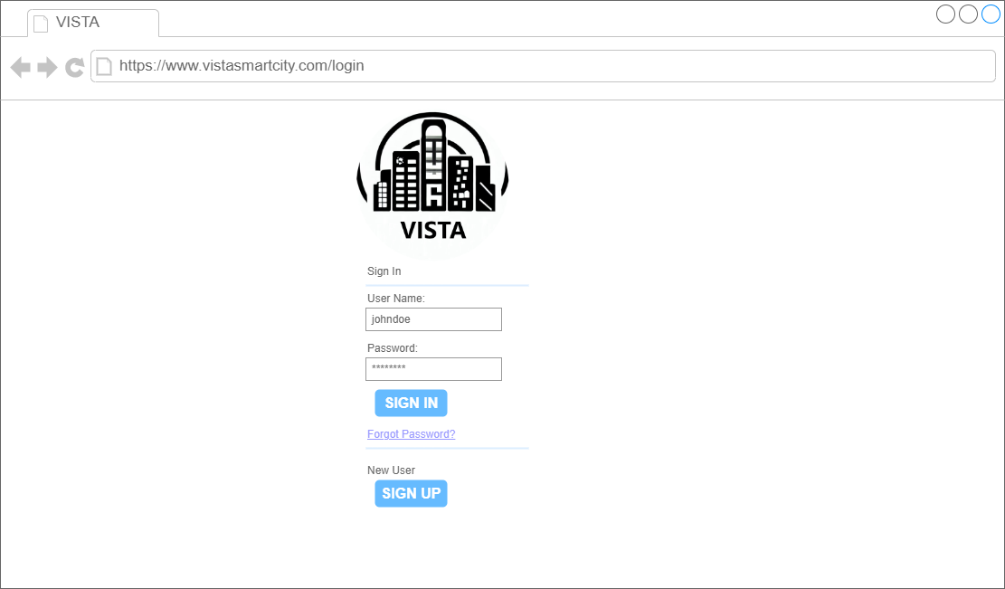
The second page presented is the main page that will be present directly after the login. In this page, there is a summary of the functionalities of the VISTA project, and the navigation bar that will always be present in every page and where the user can navigate to the page of interest. There is a section with the main pages of the site(events for the week, organizations and a search bar). There is a section for the joined events that will happen and that are already joined by the user. And finally there is a section with the upcoming volunteering events (with an event highlight) and the past activities of the user (joined events that are in the past and are already evaluated).
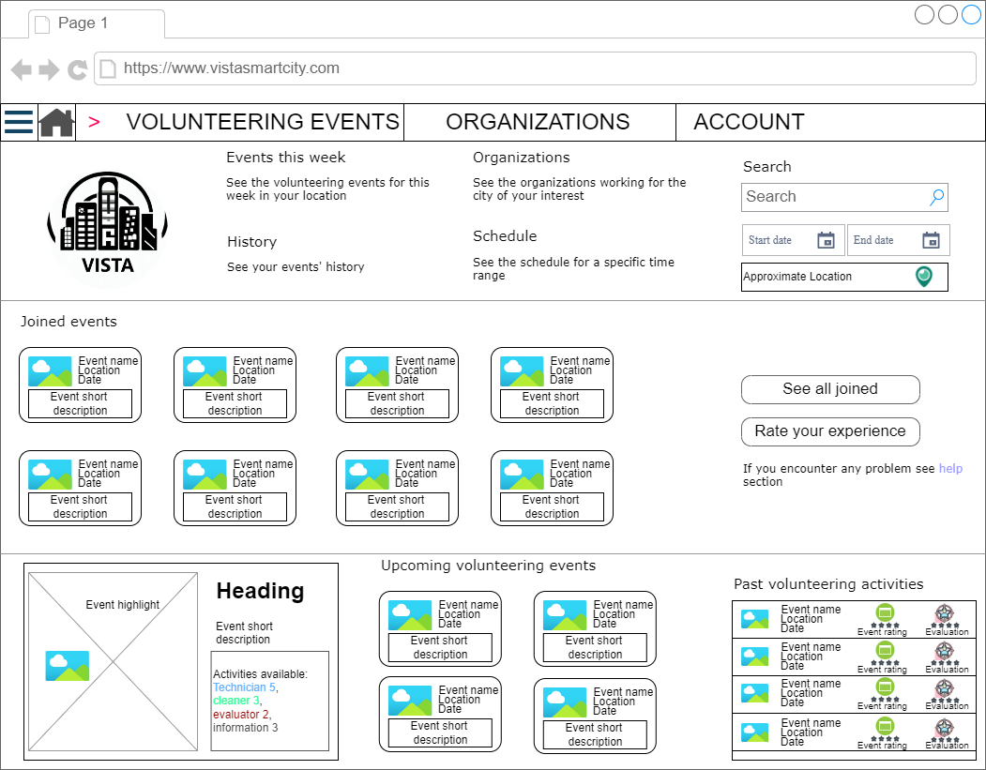
The next mock-up is of the events page, where all the events are listed(events for the week, events joined, recent event awaiting for evaluation and past events that have already been evaluated).
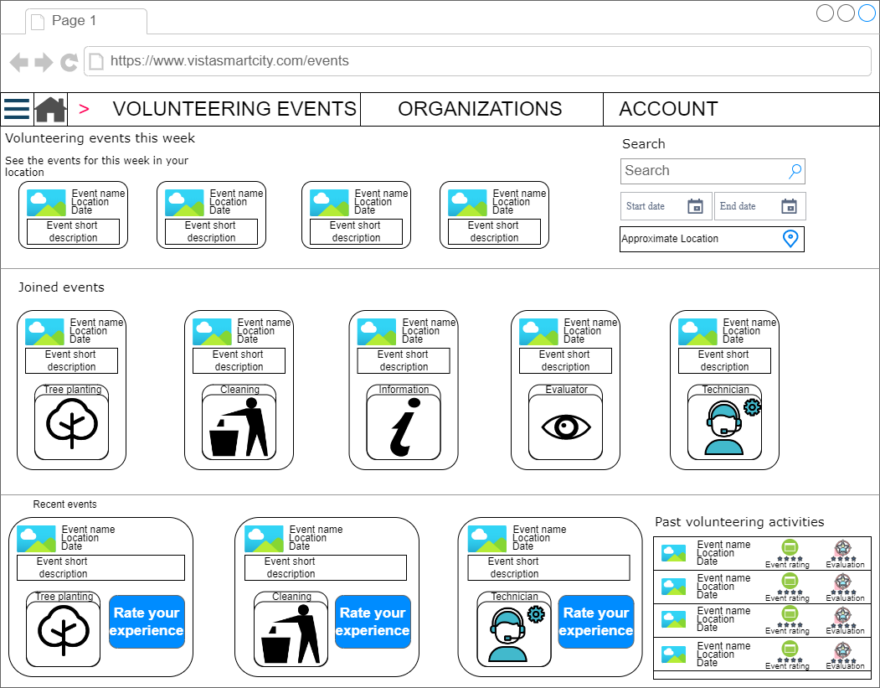
The next mock-up is of the specific event, and it shows what will be seen when selecting an event before joining it and after joining the event (some elements like the role should be also listed when the event is joined, although they are not shown in this mockup). An event has the event info, a long description, a location for the event, the organizer of the event and what are the available figures not already occupied by other users.
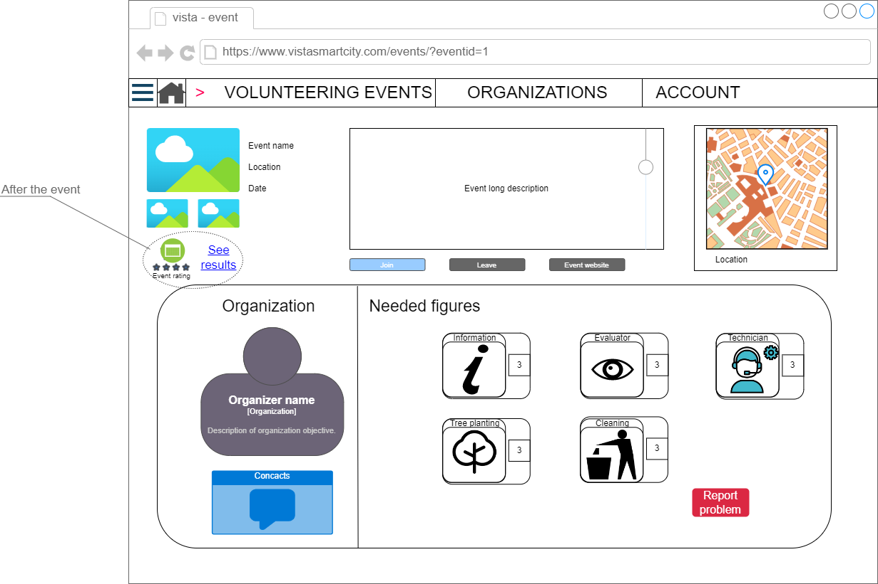
The next mock-up is about the organizations page, where all the relevant information about the organizations is listed.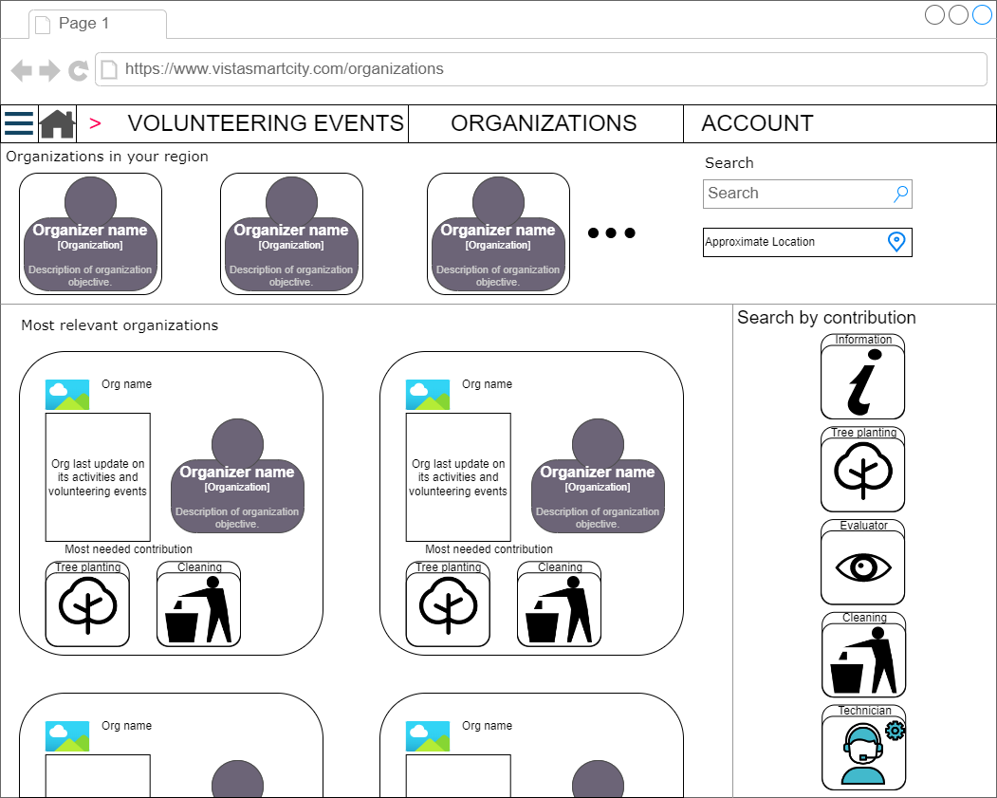
The following mock-up page is about the single organization and what can be seen about it, like its locations (more than one in some cases), the contacts, the events organized and upcoming, and the events already done with an evaluation about the overall contribution of the event to the city.
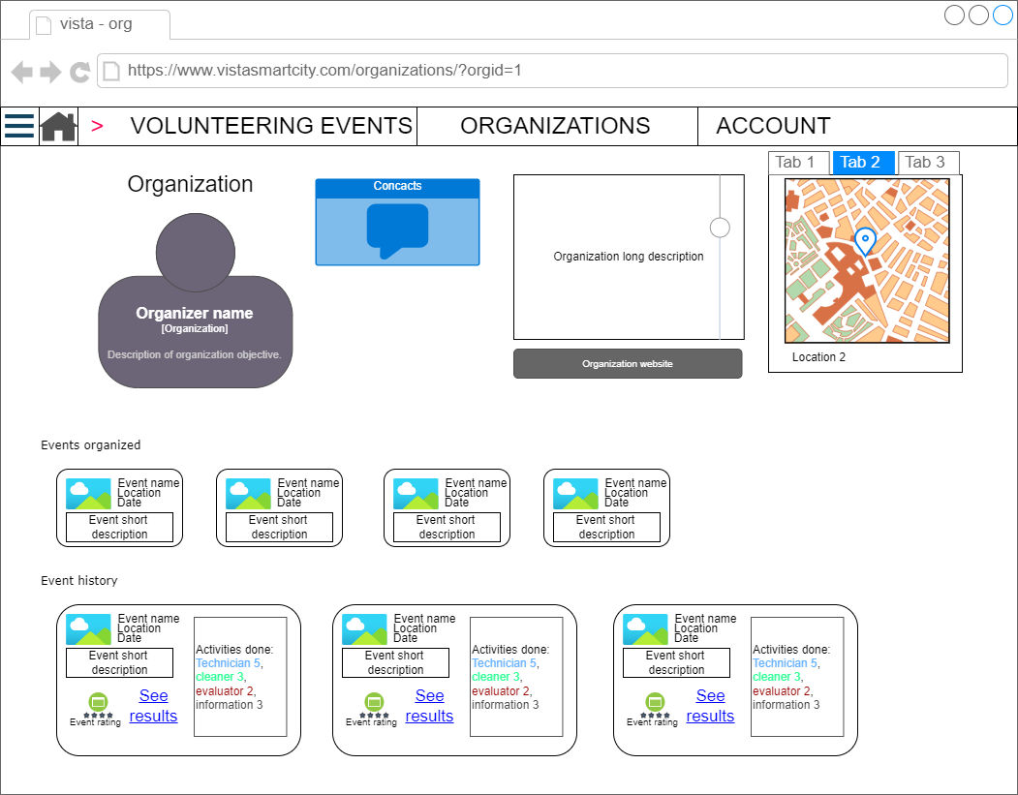
The final mock-up that I will present is about the user profile, where the user can see and customize its specialties, joined and past events and roles.
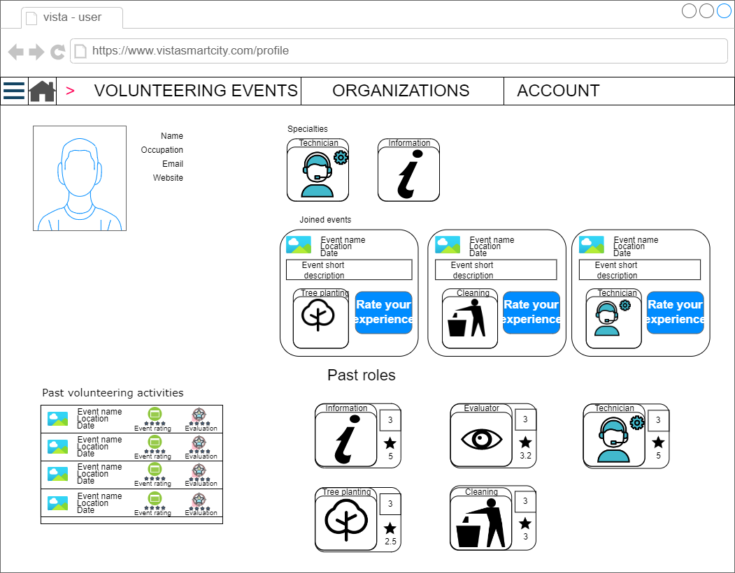
There could be other pages as well (like the results of the search for events or organizations), but the overall mock-up should be like the ones presented previously, so they will not be presented. Other pages that could be done should be the page for the creation of the event and the page for the creation of a user. The former is dependent on the organizer itself, since if the project is done, we need to consider the different needs of the different organizations, so a mock-up was not done since the final results could be completely different than what it is presented here. The latter is a common page that was not done here since it’s only a form with some boxes to compile the user information.

PRELIMINARY EVALUATION
The preliminary evaluation of the mock-up were done with the S.u.s.(system usability scale) methodology to obtain data from a sample of people (around 5 of them have also participated in the questionnaire at the start of this project), the results are the following:
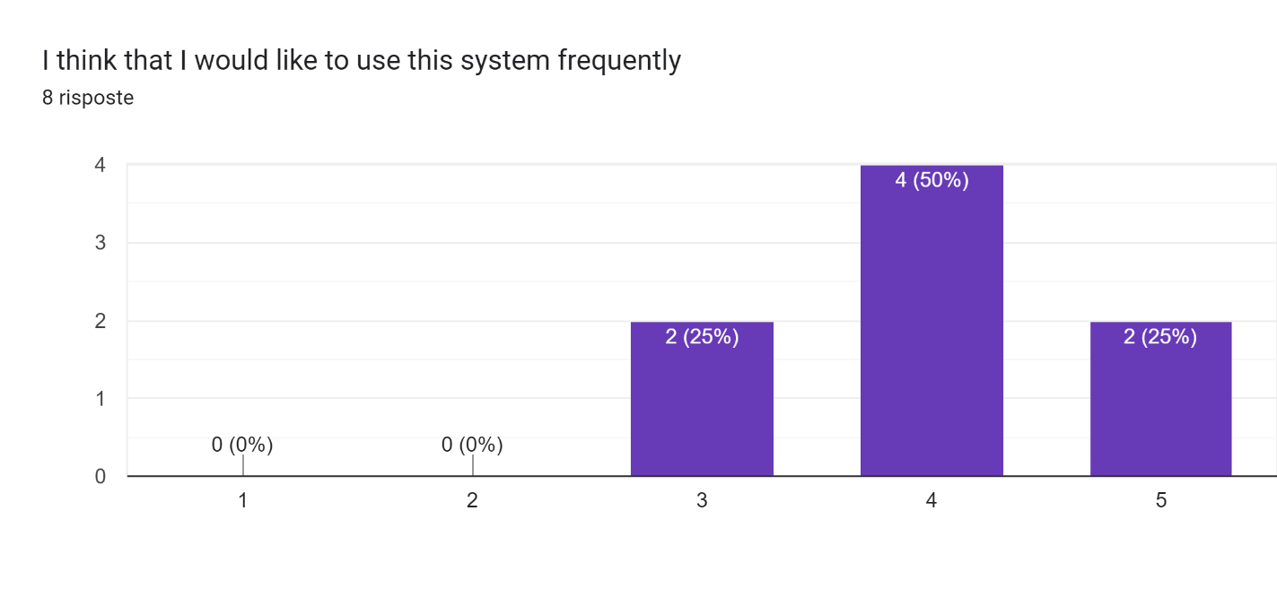
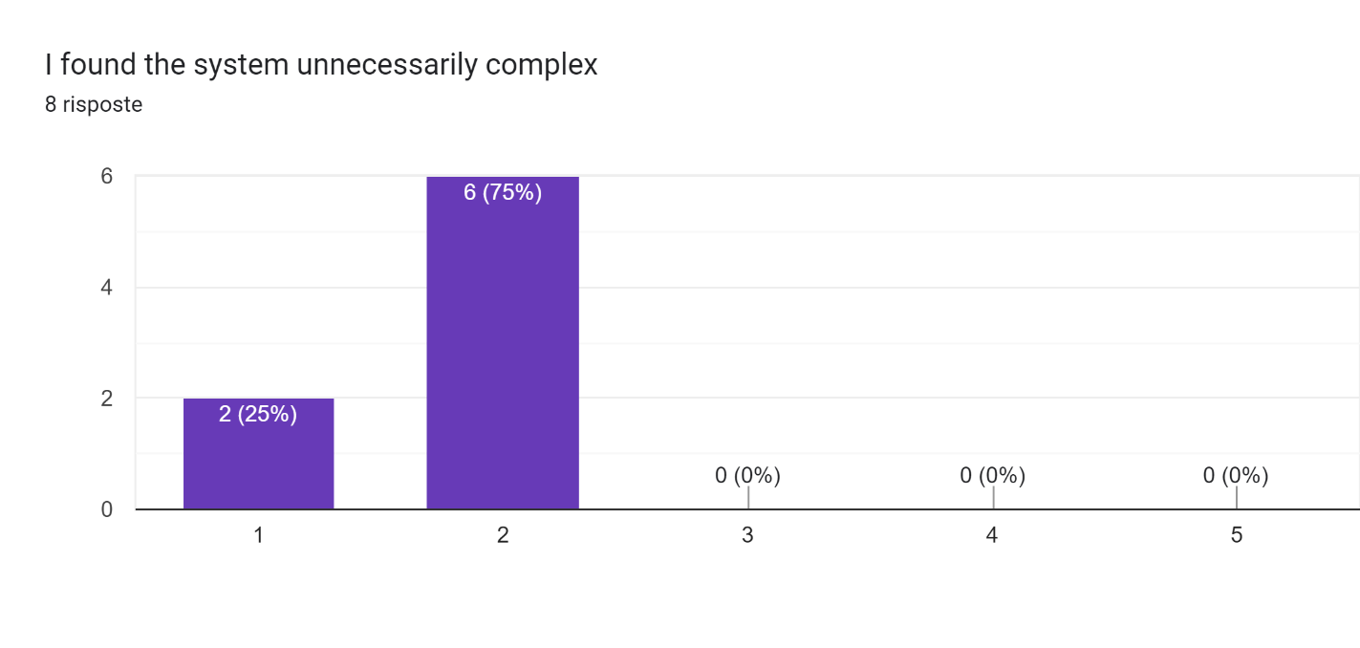
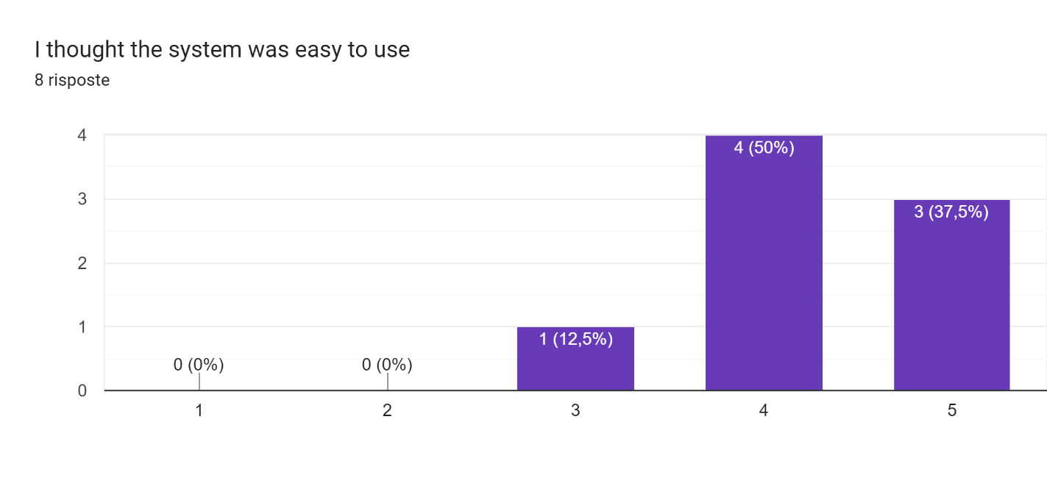
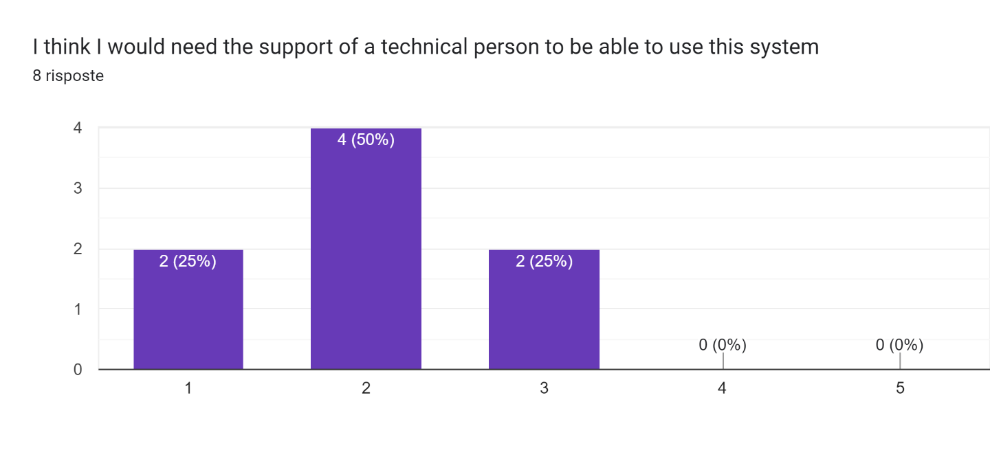
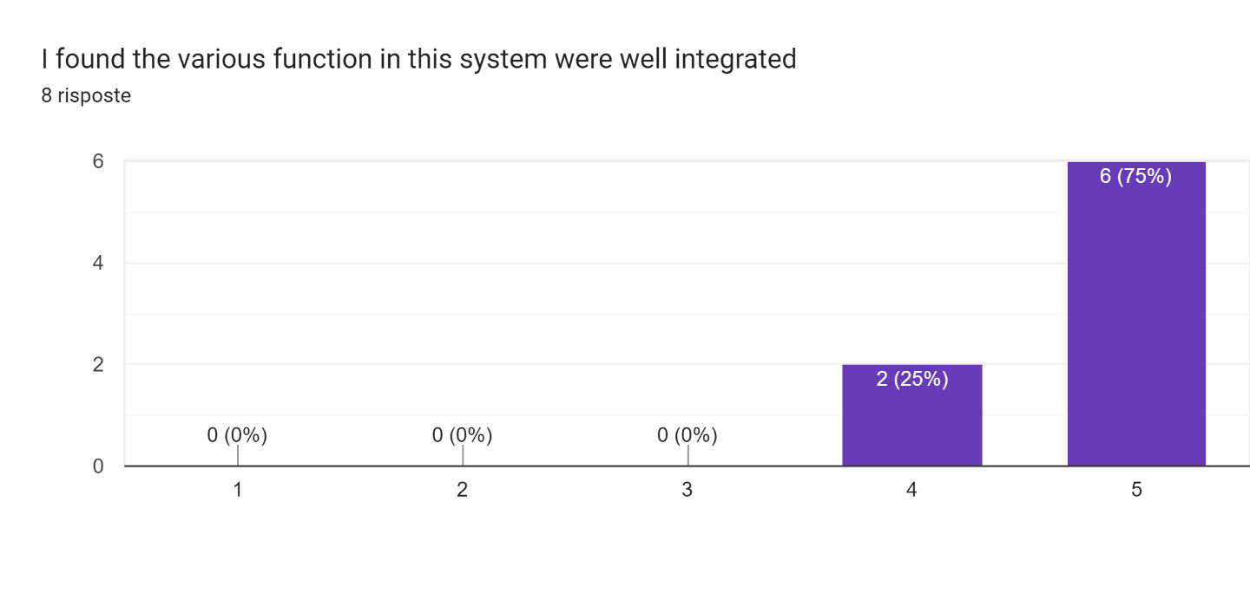
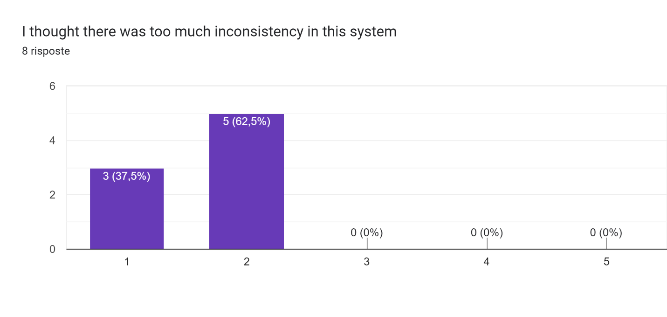
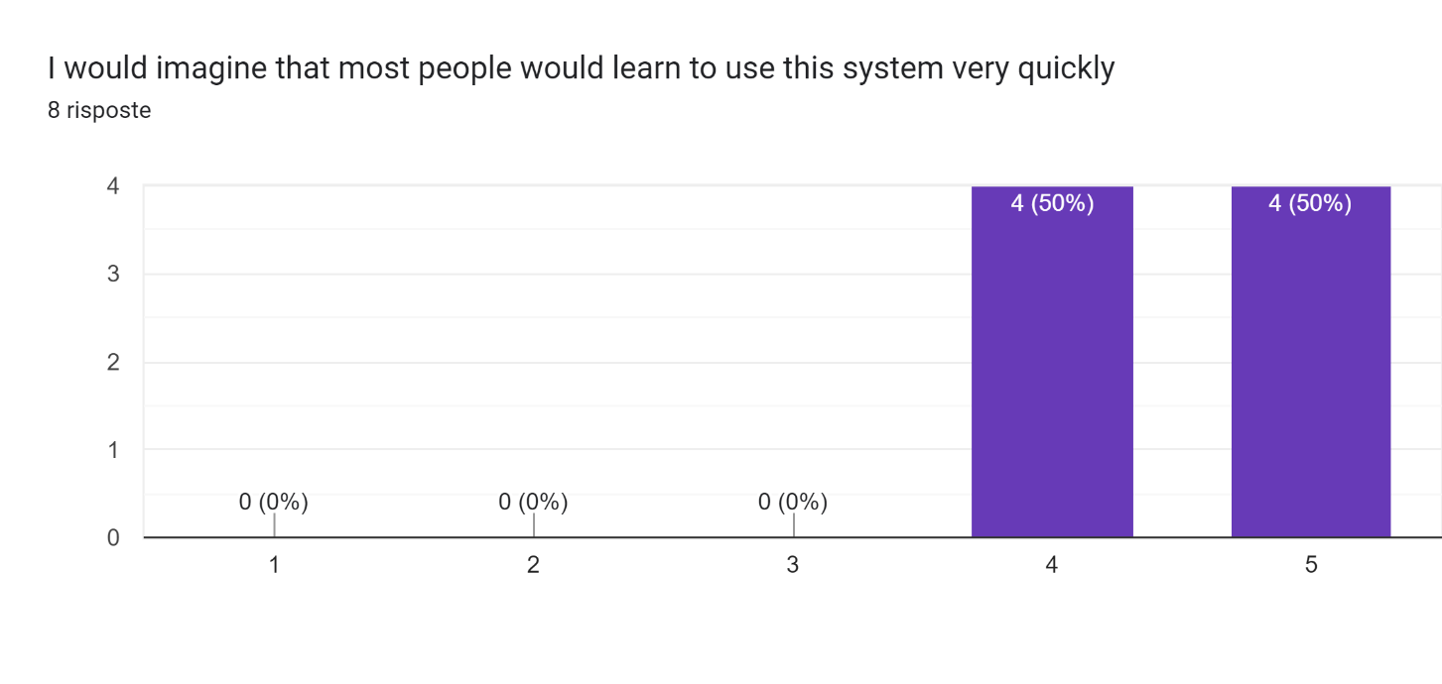
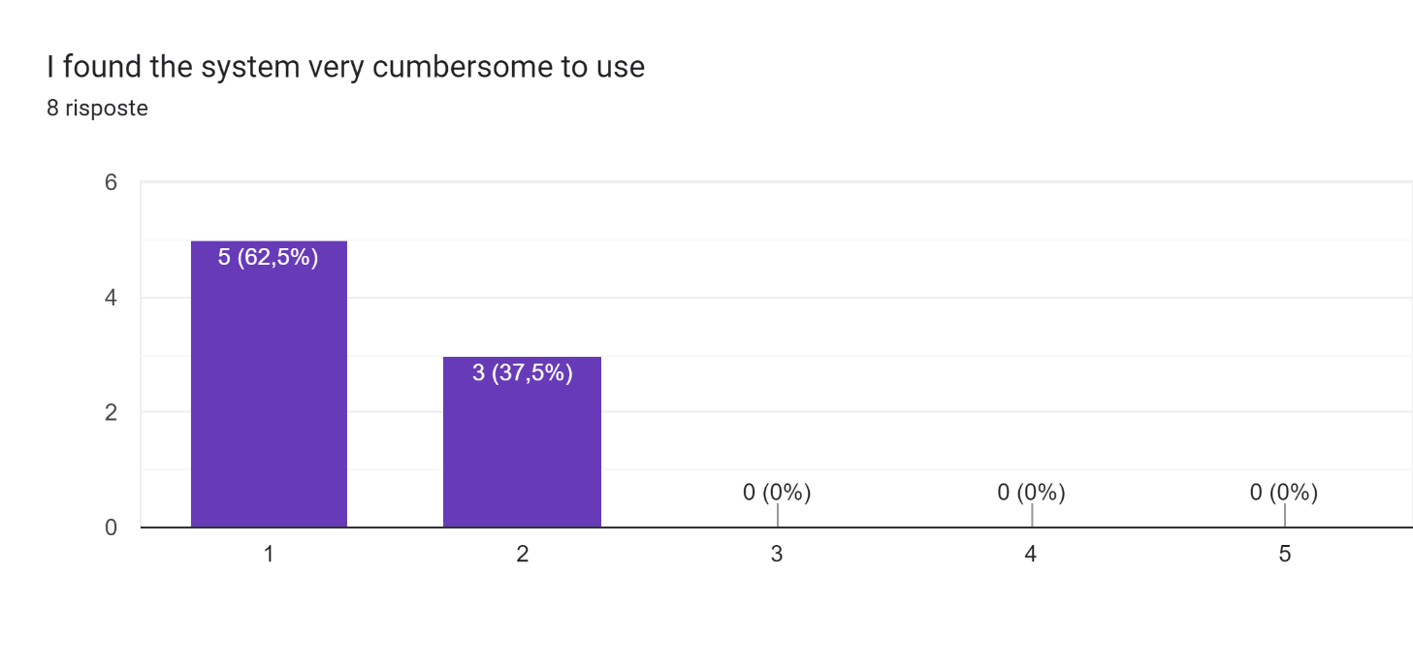
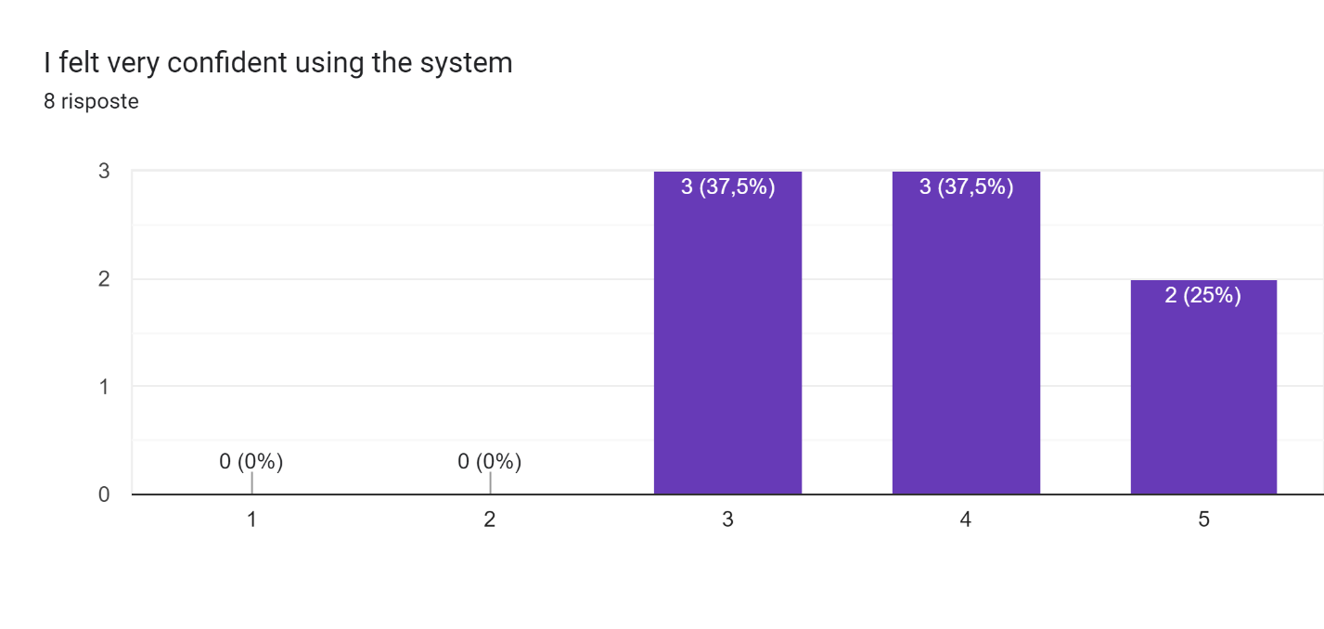
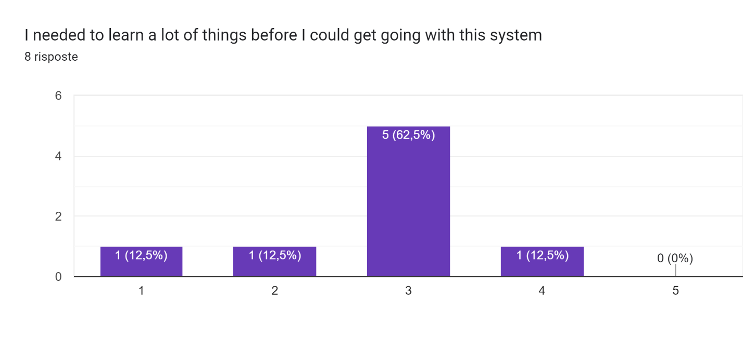
The usability score obtained from the average of every question vote of these results is the following:

Given the score results, the usability score of the mock-up and the project itself seems to be good.

CONCLUSIONS
This project was about an application to help locals contribute to volunteering event in the town where they live, the results obtained via the preliminary evaluation seems to be good since most of the people would like to use the application somewhat frequently. The mock-up was also seen as a good application, since the users did not have many problems understanding how the system should work.
The part that was not seen in this project was the part about the benefits of participating in an event and getting a good evaluation for it. That part is totally dependent on the organization itself that has organized the event, but it can also be incorporated into the application in the form of some wallet or some credits and coupons.

